Mucus Penetrating Picoeukaryote Biohybrid Robots

Aiiso Yufeng Li Family Department of Chemical and Nano Engineering, University of California San Diego, La Jolla, California 92093, United States.
†These authors contributed equally
Corresponding Authors:
David Saintillan PhD, dsaintillan@ucsd.edu
Liangfang Zhang, PhD, zhang@ucsd.edu
Joseph Wang, PhD, josephwang@ucsd.edu

Abstract
Mucus is an essential biological barrier that protects mucosal tissues but severely limits the transport of common passive and active drug carriers, posing a major challenge for mucosal targeted drug delivery and limiting the therapeutic efficacy. Here, we develop a picoalgae-based biohybrid nanorobotic platform for active mucus penetration. The ultrasmall picoeukaryote Micromonas pusilla, with a body size of approximately 1 μm and high swimming speeds of up to 60 body lengths per second, provides sustained, fuel-free propulsion through dense mucin networks. Detailed motion characterization and modeling of the nanorobotic swimmers reveal how mucus affects the biohybrid robot locomotion, providing insights into their interactions with the mucin network. Studies involving picoeukaryote carrying payloads of different sizes and analyzing their corresponding motion behaviors further demonstrate that robot motility strongly depends on the relative size of the robot and the mucus mesh. In vivo experiments demonstrate the excellent mucus penetration of picoalgae robots and their improved organ distribution and retention in lung, GI and vagina (compared to motion-free static algae). These findings establish biohybrid picoalgae robots as intrinsically motile and biocompatible nanoswimmers capable of actively traversing multiple mucus barriers, providing a promising platform for mucosal drug delivery.

INTRODUCTION
Mucus is a major biological barrier found in multiple organs throughout the human body that covers mucosal interface (1-3). The mucus layers contain a highly viscoelastic polymer network, consisting of crosslinked, negatively charged mucin, that protect against pathogens and toxic substances while restricting the mobility of most drug carriers (4). Mucins are highly glycosylated proteins which contain abundant hydrophilic groups that strongly bind water, they can absorb more than 1,000 times their mass of water and form an entangled, hydrated network that is essential for barrier function (7). At the macroscale, mucus behaves as a non-Newtonian gel, while at the nanoscale it behaves as a low-viscosity fluid (8). Importantly, previous studies have shown that mucin network mesh size is a key factor governing the penetration behavior of therapeutic particles and exogenous pathogens (9). Particles with dimensions comparable to the mucin network exhibit more efficient movement within mucus, whereas larger particles are more likely to be trapped and cleared more rapidly (10). A variety of mucus-penetration strategies, aimed at lowering the interacting between particles and mucus, including PEG-modified particles, have been developed (11-14). However, their penetration efficiency remains limited in thick and heterogeneous mucus due to their reliance on passive diffusion, limiting their ability to reach deeper mucosal regions to achieve therapeutic functions. Overall, mucus presents a formidable barrier and challenge for drug delivery, and there is a critical need to overcome this barrier without compromising its protective and hydrating functions.
Nano/microrobotics have recently attracted considerable attention for their potential to overcome biological barriers through their active propulsion (15-19). Unlike passive drug carriers that rely solely on passive diffusion, micro- and nanorobots generate mechanical forces that enable self-propulsion and active transport in viscous and heterogeneous environments (20,21). Several microrobotic strategies have been developed to achieve mucus penetration (XX-YY). For example, pioneering studies have reduced the size of helical magnetic microrobots to less than 1 μm, a dimension comparable to the mucus network mesh size, thereby facilitating locomotion and drug delivery through ocular mucus (20, 22-23). Other approaches employed synthetic motors powered by chemical fuels or photocatalytic reactions to enhance mucus penetration (17, 24-25). Although these strategies enable effective mucus penetration, developing autonomous robotic systems capable of fuel-free locomotion without external stimuli is highly desirable for practical applications. Recently emerged biohybrid microrobots offer long-lasting natural propulsion without the requirement of fuel in complex biological fluids and considerable promise for drug delivery applications (26-28). However, to the best of our knowledge, their application in overcoming biological barriers, especially mucus penetration, has largely been unexplored.
In this work, we introduce a picoalgae-based biohybrid nanorobotic platform for active mucus penetration. The picoeukaryote Micromonas pusilla has an average diameter of approximately 1 μm, which is comparable to the network mesh size of many mucus systems. The ultrasmall size of these biohybrid microrobots, together with their naturally high motility of up to 60 body lengths per second, enables them to swim and navigate autonomously through mucin networks. Interestingly, we found that the algae robots exhibit larger circular trajectories with an increased radius of motion and mean square displacement in the presence of mucus. Detailed analysis and modeling of their motion behavior provide additional insights into this unique mucus-penetrating behavior and demonstrate that they are suitable for a range of mucus targeted applications. The algae were subsequently modified with payloads of different sizes, including cell membrane nanodiscs (CNDs, 20 nm) and PLGA nanoparticles (PLGA NPs, 100 and 250 nm), resulting in biohybrid robots with different overall sizes. The motion behavior of these functionalized robots was then investigated in mucus, revealing that their swimming behavior is strongly influenced by the mucin network. To explore the functional applications of our biohybrid robots, we further functionalized the picoalgae with dexamethasone-loaded CNDs to demonstrate their drug delivery capabilities and therapeutic efficacy. In vitro experiments, including Transwell assays, demonstrated that the modified picoalgae robots can swim through and traverse different mucus environments, indicating effective propulsion within highly entangled mucin networks. Finally, in vivo studies demonstrated the efficient mucus penetration capabilities of the biohybrid microrobots across three mucus-rich organs, including the lung, gastrointestinal tract, and vagina. Compared with static controls, the active biohybrid robots exhibited excellent mucus penetration, enhanced distribution and prolonged organ retention, showing their potential for diverse mucosal applications. Overall, this work shows biohybrid picoalgae robots as an active platform for mucus penetration. Their ultrasmall size, fast and sustained propulsion, and biological compatibility enable efficient navigation through mucus barriers, offering new opportunities for mucus-targeted drug delivery and mucosal therapies.
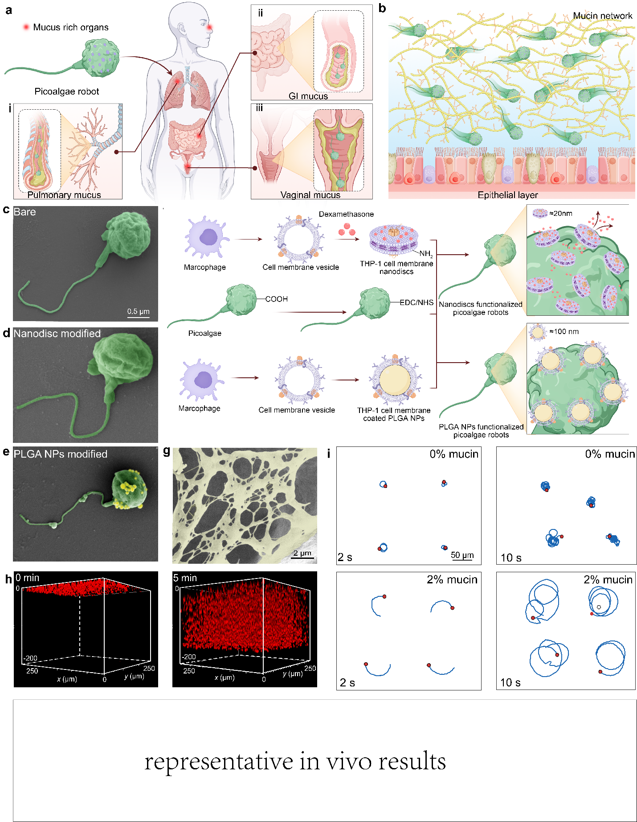
Figure 1. a, Cartoon illustration of picoalgae robots penetrating three mucus-rich organs in the human body. b, Detailed illustration of picoalgae robots penetrating the mucin network. c-e, SEM images of bare (c), macrophage nanodisc, and PLGA NP -modified picoalgae robots . f. The functionalization processes of cell membrane-coated PLGA NPs and derived nanodiscs modified picoalgae robots. g, A typical SEM image of a 2% mucin network after lyophilization. h, 3D confocal microscopy images showing bare picoalgae penetrating 2% mucin at 0 and 5 min. i, Motion trajectories of bare picoalgae in 0% mucin and 2% mucin at 2 and 10 s.
Figure 1a illustrates the concept of using picoalgae robots to penetrate thick mucus in three mucus-rich organs, including lung, GI and vagina. Owing to their small body size, picoalgae can actively traverse the mucus network and reach the underlying epithelial surface (Figure 1b). A representative SEM image of bare picoalgae is shown in Figure 1c, indicating a body size of approximately 1 μm and a single flagellum for propulsion. To investigate the effects of payload size, we modified the picoalgae with macrophage CNDs (Figure 1d) and cell membrane-coated PLGA NPs (Figure 1e). The picoalgae surface contains carboxyl (–COOH) groups that provide reactive sites for covalent functionalization. As illustrated in Figure 1f, THP-1 CNDs and cell membrane-coated PLGA NPs were conjugated to the picoalgae via EDC/NHS-mediated covalent coupling. To visualize the network structure of the mucin solution, a 2% mucin solution was lyophilized and as shown in the SEM image in Figure 1g, the mucin network exhibits highly entangled structures with pore sizes ranging from several hundred nanometers to approximately 2 μm. To demonstrate the ability of picoalgae robots to cross the mucus barrier, bare picoalgae were introduced onto a 2% mucin layer and their penetration behavior was examined by confocal microscopy. Initially, the algae predominantly accumulated at the mucus surface, whereas after 5 min, a substantial fraction has penetrated into the mucus layer, demonstrating their efficiency for active mucus penetration (Figure 1h). The motion of bare picoalgae was subsequently characterized in 0% and 2% mucin, as shown in Figure 1i. In the absence of mucin, the algae exhibited fast propulsion driven by their specialized flagellar rotation, which generates propeller-like propulsive thrust. Over trajectories of 2 and 10 s, they predominantly exhibited circular motion near the boundary, likely due to hydrodynamic coupling and close interactions with the substrate (29). Interestingly, in the presence of 2% mucin, the bare algae exhibited a much larger radius of motion and enhanced translational swimming. This effect may arise because the three-dimensional gel network structure of mucus alters the local rheological environment and limits surface interactions with the underlying substrate, enabling the rotation of helical algal flagella to effectively drive long-range movement (30). XXX David’s Inputs on unique behaviorXXX In-vivo studies involving three different mucus barriers demonstrate the crucial role of the efficient motion of these tiny biohybrid microrobots towards enhancing the distribution and retention compared to their static counterparts. These results highlight the potential of picoalgae as small-scale biological robots capable of actively operating and transporting cargo within complex mucus environments.
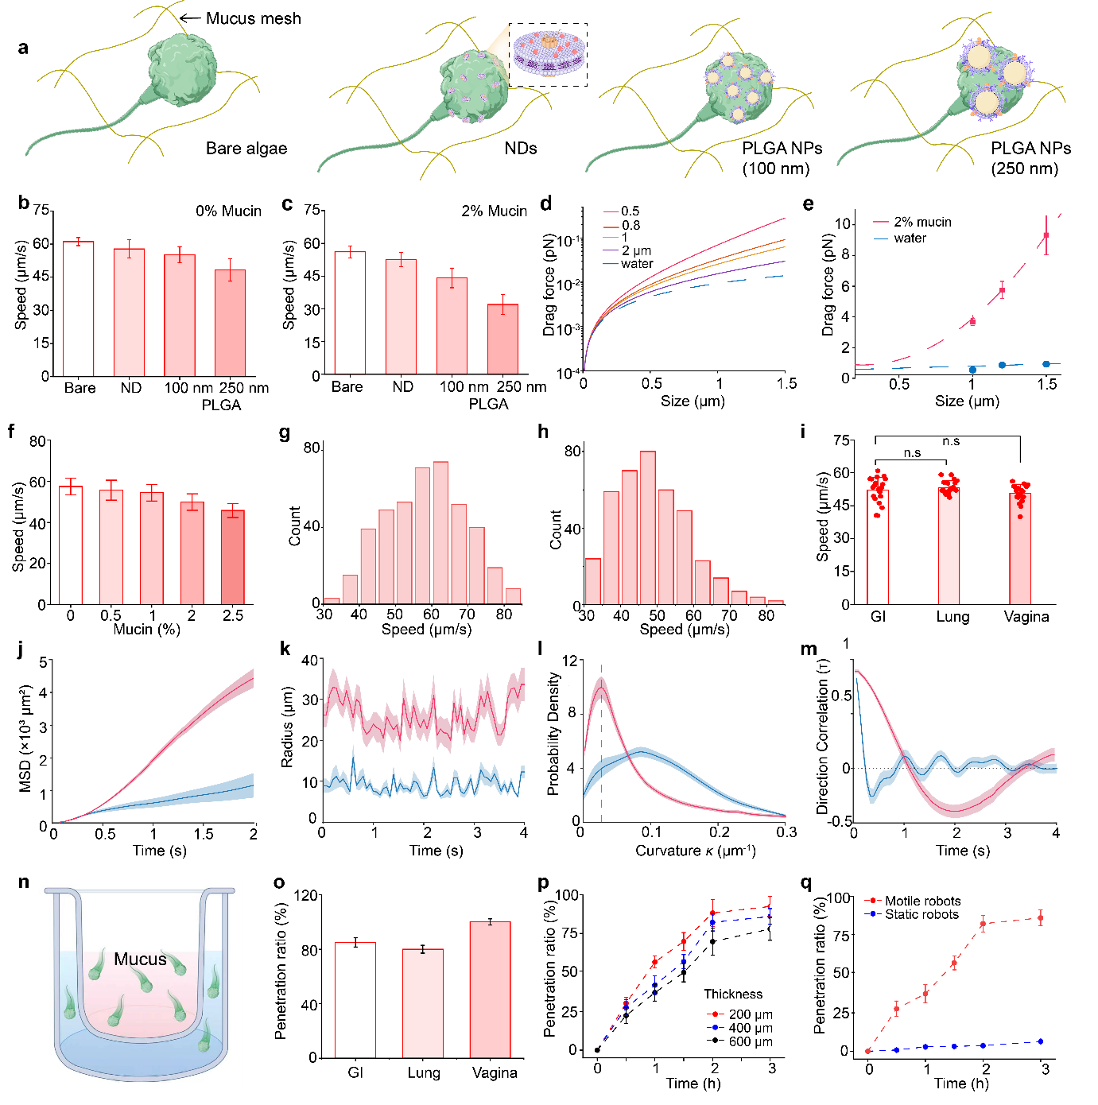
Figure 2. a, Schematic illustration of bare picoalgae and nanodisc (ND)- and PLGA NP-modified picoalgae robots penetrating the mucin network. The interaction with the mucus network becomes stronger as the overall size of the robot increases. b-c, Swimming speed of bare algae and CNDs and PLGA NPs modified picoalgae robots with 100 and 250 nm PLGA NPs in 0% and 2% mucin. d, Drag force as a function of swimmer size relative to the mesh size of the mucus network. e, Drag force of picoalgae robots with three different overall sizes and payloads. f, Swimming speed of macrophage cell membrane-derived nanodisc-modified picoalgae in 0-2.5 wt% mucin. g-h, Speed distributions of CND-modified picoalgae in 0% (g) and 2% (h) mucin. i, Swimming speed of macrophage cell membrane-derived nanodisc-modified picoalgae in three types of artificial mucus. j, Ensemble-averaged mean squared displacement (MSD) of macrophage cell membrane-derived nanodisc-modified picoalgae in 0% (blue) and 2% (red) mucin over 2 s. k, Radius of curvature of CNDs modified picoalgae in 0% and 2% mucin. l, Curvature of CNDs modified picoalgae in 0% and 2% mucin. m, Directional correlation factor of CNDs modified picoalgae in 0% and 2% mucin. n, Schematic illustration of the picoalgae robots in a Transwell setup. o, Penetration ratio of CNDs modified picoalgae in three types of artificial mucus. p, Mucus penetration of CNDs modified picoalgae through artificial lung mucus with different thicknesses. q, Mucus penetration of motile and static CNDs modified picoalgae through artificial lung mucus.

To further investigate the mucus-penetration behavior of our picoalgae platform, we modified the algae with payloads of different sizes, as shown in Figure 2a. The motion of four types of algae robots were evaluated: bare algae, nanodisc (ND)-modified algae, and PLGA NP-modified algae with 100 and 250 nm PLGA NPs. The swimming speeds of these four types of algae robots in 0% and 2% mucin solutions were measured and are shown in Figure 2b-c. The algae robots exhibited progressively slower motion in water, decreasing from 60 to 51.5 μm/s, as the payload size increased. However, a more pronounced decrease in swimming speed was observed in 2% mucin when the algae were modified with 250 nm PLGA NPs. This decrease is likely attributed to the stronger interactions between the larger robots and the mucin mesh network, which can be estimated by the following equation:(1)
$$f≈f_{0} exp\left(β{\left(\frac{L}{χ}\right)}^{δ}\right)$$
where f is the resistance to motion, f₀ is the resistance in pure solvent, L is the characteristic particle size, χ is the mesh size, β is the scaling parameter (β ≈ 1), and δ is an exponent parameter usually assumed to be 1 (δ ≈ 1). The size-dependent swimming behavior of the robots as a function of the mucus network mesh size is further illustrated in Figure 2d, while the resistance forces of the three types of functionalized robots are shown in Figure 2e. The resistance force increased approximately linearly with robot size in the absence of mucus, whereas it increased exponentially in the presence of the mucin network. Because the CNDs modified algae had the smallest overall size among the functionalized robots, we selected this formulation for subsequent studies. As shown in Figure 2f, the swimming speed of the CNDs modified algae robots decreased from 61 to 55 μm/s as the mucin concentration increased from 0 to 2.5 wt%. The corresponding speed distributions at 0% and 2% mucin are shown in Figure 2g-h. To demonstrate the versatility of the picoalgae platform for penetrating different types of mucus, the swimming behavior of the CNDs modified algae robots was evaluated in three types of artificial mucus. The algae robots maintained high swimming speeds of 55.3, 56.2, and 53.7 μm/s in GI, lung, and vaginal mucus, respectively, highlighting their potential for applications across multiple mucosal organs. To further investigate the detailed motion behavior of the CNDs modified algae in mucus, we characterized their motion in 0% and 2% mucin and analyzed their mean squared displacement (MSD), as shown in Figure 2j. The algae robots exhibited a substantially larger MSD in the presence of mucus. In the absence of mucus, strong interactions with the underlying substrate constrained the algae into relatively small circular trajectories. In contrast, the three-dimensional mucin network reduces direct interactions between the algae and the substrate, allowing them to undergo larger trajectories and achieve greater displacement. The radius of the average motion trajectories was further analyzed, as shown in Figure 2k. The algae robots exhibited a larger average radius of motion in the presence of mucin. A similar trend was observed for trajectory curvature, with the algae exhibiting lower curvature in 2% mucin than in 0% mucin (Figure 2l), consistent with their larger-radius trajectories. Figure 2m further characterizes the directional correlation of algae motion. In the absence of mucus, algae swam in tight circular paths with rapid direction changes, resulting in greater fluctuations in directional correlation. In contrast, algae in 2% mucin followed larger circular trajectories, exhibiting more persistent directional motion with smoother direction changes. Collectively, these unique swimming behaviors demonstrate the ability of picoalgae robots to adapt their locomotion to mucus environments, supporting their potential for active transport across mucosal barriers. To further evaluate the mucus-penetrating performance of the picoalgae robots, a Transwell assay was conducted using 400 μm-thick mucus layers (Figure 2n). After 3 h of incubation, the robots exhibited high penetration efficiencies across various tissue sources (Figure 2o), reaching penetration ratios of 85.3% in GI mucus, 80.4% in lung mucus, and nearly 100% in vaginal mucus. Figure 2p further examines the penetration behavior of the picoalgae robots through 200, 400, and 600 μm-thick artificial lung mucus, demonstrating their penetration capability across all tested mucus thicknesses. It should be noted that the average thickness of mucus layers in the human body is generally below 200 μm, although it varies substantially depending on the anatomical location and physiological conditions (1). Finally, Figure 2q compares the penetration of motile picoalgae robots with that of static algae controls. After 3 h, the motile robots achieved an 81% penetration ratio, whereas only 7% of the static control group penetrated the lung mucus, highlighting the critical role of active propulsion in mucus penetration. These results further demonstrate that the picoalgae robots can actively traverse and penetrate mucus barriers owing to their ultrasmall size and sustained propulsion, showing their potential as active carriers for mucosal drug delivery.

Conclusion
In summary, we have developed a biohybrid nanorobotic platform based on the picoeukaryote Micromonas pusilla (~1 μm) for fuel-free propulsion across complex mucus barriers. Utilizing high natural motility of up to 60 body lengths per second and a body size comparable to mucus mesh pores, these swimmers effectively traverse dense mucus networks. Payload functionalization studies with cell membrane nanodiscs (~20 nm) and PLGA nanoparticles (100 and 250 nm) demonstrate size-dependent motility behavior in mucus, where smaller nanodisc modifications minimize steric drag within the mucin network. Modeling and motion analysis show that the interaction between mucus and algae robots further provides insights into how to design future barrier-penetrating small-scale robots. Furthermore, in vitro therapeutic assays and in vivo mucus penetration studies across pulmonary, gastrointestinal, and vaginal sites confirm that active picoalgae achieve superior barrier penetration, distribution, and retention compared to static controls. Overall, this intrinsically motile and biocompatible platform provides a novel active delivery strategy for mucosal therapeutics.REFERENCES
1. R. A. Cone, Barrier properties of mucus. Advanced Drug Delivery Reviews 61, 75-85 (2009).
2. J. V. Fahy, B. F. Dickey, Airway Mucus Function and Dysfunction. New England Journal of Medicine 363, 2233-2247 (2010).
3. R. Bansil, B. S. Turner, The biology of mucus: Composition, synthesis and organization. Advanced Drug Delivery Reviews 124, 3-15 (2018).
4. M. Boegh, H. M. Nielsen, Mucus as a Barrier to Drug Delivery – Understanding and Mimicking the Barrier Properties. Basic & Clinical Pharmacology & Toxicology 116, 179-186 (2015).
5. J. Witten, T. Samad, K. Ribbeck, Selective permeability of mucus barriers. Current Opinion in Biotechnology 52, 124-133 (2018).

4. J. K. Gustafsson, M. E. V. Johansson, The role of goblet cells and mucus in intestinal homeostasis. Nature Reviews Gastroenterology & Hepatology 19, 785-803 (2022).
5. A. McShane et al., Mucus. Current Biology 31, R938-R945 (2021).
6. G. C. Hansson, Mucins and the Microbiome. Annual Review of Biochemistry 89, 769-793 (2020).
7. P. Paone, P. D. Cani, Mucus barrier, mucins and gut microbiota: the expected slimy partners? Gut 69, 2232-2243 (2020).
8. S. K. Lai, Y.-Y. Wang, D. Wirtz, J. Hanes, Micro- and macrorheology of mucus. Advanced Drug Delivery Reviews 61, 86-100 (2009).
9. J. Celli et al., Viscoelastic Properties and Dynamics of Porcine Gastric Mucin. Biomacromolecules 6, 1329-1333 (2005).
10. C. S. Schneider et al., Nanoparticles that do not adhere to mucus provide uniform and long-lasting drug delivery to airways following inhalation. Science Advances 3, e1601556 (2017).
11. S. K. Lai et al., Rapid transport of large polymeric nanoparticles in fresh undiluted human mucus. Proceedings of the National Academy of Sciences 104, 1482-1487 (2007).
12. P. Mastorakos et al., Highly compacted biodegradable DNA nanoparticles capable of overcoming the mucus barrier for inhaled lung gene therapy. Proceedings of the National Academy of Sciences 112, 8720-8725 (2015).
13. L. M. Ensign et al., Mucus-Penetrating Nanoparticles for Vaginal Drug Delivery Protect Against Herpes Simplex Virus. Science Translational Medicine 4, 138ra179-138ra179 (2012).
14. S. K. Lai, Y.-Y. Wang, J. Hanes, Mucus-penetrating nanoparticles for drug and gene delivery to mucosal tissues. Advanced Drug Delivery Reviews 61, 158-171 (2009).
15. J. Li, B. Esteban-Fernández de Ávila, W. Gao, L. Zhang, J. Wang, Micro/nanorobots for biomedicine: Delivery, surgery, sensing, and detoxification. Science Robotics 2, eaam6431 (2017).
16. C. Gao et al., Biomedical Micro-/Nanomotors: From Overcoming Biological Barriers to In Vivo Imaging. Advanced Materials 33, 2000512 (2021).
17. Z.-H. Wang et al., Bioactive nanomotor enabling efficient intestinal barrier penetration for colorectal cancer therapy. Nature Communications 16, 1678 (2025).
18. S. Huang et al., Micro/Nanomotors Actively Penetrate Physiological Barriers: Basic Nanoarchitectonics to Practical Application. Advanced Materials 38, e08865 (2026).
19. X. Ju et al., Technology Roadmap of Micro/Nanorobots. ACS Nano 19, 24174-24334 (2025).
20. D. Schamel et al., Nanopropellers and Their Actuation in Complex Viscoelastic Media. ACS Nano 8, 8794-8801 (2014).
21. J. Wang, Nanomachines: Fundamentals and Applications, Wiley-VCH, Weinheim, 2013.
22. D. Walker, B. T. Käsdorf, H.-H. Jeong, O. Lieleg, P. Fischer, Enzymatically active biomimetic micropropellers for the penetration of mucin gels. Science Advances 1, e1500501 (2015).
23. Z. Wu et al., A swarm of slippery micropropellers penetrates the vitreous body of the eye. Science Advances 4, eaat4388 (2018).
24. H. Yu et al., Photocatalytic microrobots for treating bacterial infections deep within sinuses. Science Robotics 10, eadt0720 (2025).
25. Z.-H. Wang et al., Biological chemotaxis-guided self-thermophoretic nanoplatform augments colorectal cancer therapy through autonomous mucus penetration. Science Advances 8, eabn3917 (2022).
26. F. Zhang et al., Biohybrid Microalgae Robots: Design, Fabrication, Materials, and Applications. Advanced Materials 36, 2303714 (2024).
27. D. B. Weibel et al., Microoxen: Microorganisms to move microscale loads. Proceedings of the National Academy of Sciences 102, 11963-11967 (2005).
28. Y. Che, X. Song, L. Zhang, Engineering microalgae-based biohybrid robots for biomedical applications. Cell Biomaterials 1, (2025).
29. E. Lauga, W. R. DiLuzio, G. M. Whitesides, H. A. Stone, Swimming in Circles: Motion of Bacteria near Solid Boundaries. Biophysical Journal 90, 400-412 (2006).
30. J. Witten, T. Samad, K. Ribbeck, Selective permeability of mucus barriers. Curr. Opin. Biotechnol. 52, 124-133 (2018).

